## User Interfaces Design

### Game Description

At the beginning, the user enters to PNOTCA application by pressing the logo icon ( Figure ‎4.2.1 ). Then the specialist registering by entering the required fields as shown at ( Figure ‎4.2.2 ). Once the registration process completed the games may start by press the start button ( Figure ‎4.2.3 ). The specialist has the choice to select the category to be assessed, POTCA has three categories: pattern matching, object identification and puzzle (Figure ‎4.2.4 ). After selecting the category, he/she has to select the suitable level ( Figure ‎4.2.5) to start the game.



**Figure ‎4.2.1 : PNOTCA Logo**

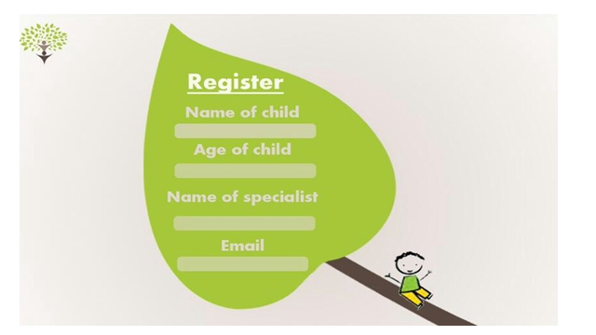

**Figure ‎4.2.2: Register Interface**

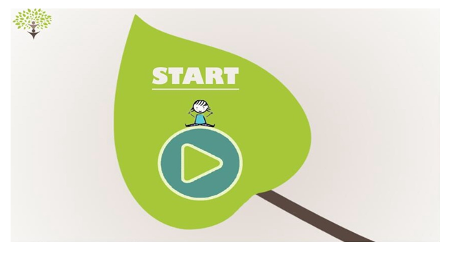

**Figure ‎4.2.3 : Start Interface**

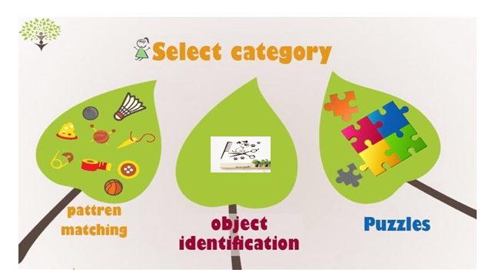

**Figure ‎4.2.4: Select Category Interface**

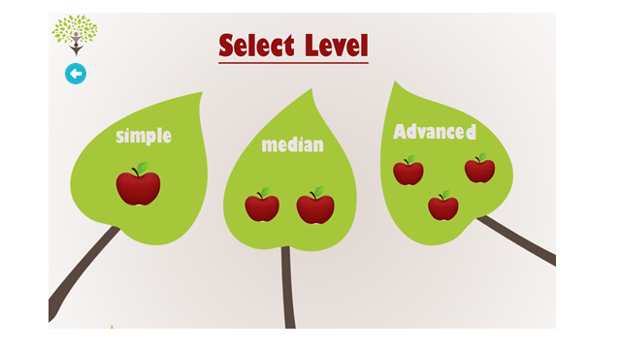

**Figure ‎4.2.5 : Select Level Interface**

### Puzzle Category Interfaces

In this category, a puzzle game is produced for the child to play. The puzzle consists of set of pieces that should be put together in a logical way, in order to reach the correct solution of the puzzle to complete the picture. The puzzle game will be divided into three levels: Simple Level when the puzzle consists of only four pieces, Median Level when the puzzle consists of nine pieces and Advanced Level when the puzzle consists of twelve pieces to complete the picture.

#### Simple Level of puzzle interfaces

This level includes two games, the specialist have to select one of them .see ( Figure ‎4.2.6 ) so that the child will play the selected puzzle, see ( Figure ‎4.2.7,Figure ‎4.2.8) .

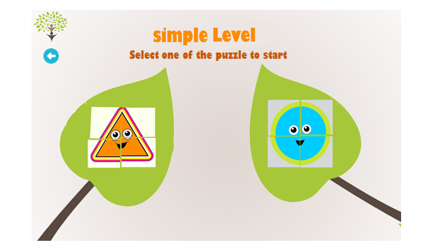

**Figure ‎4.2.6 : Select the Puzzle in Simple Level**

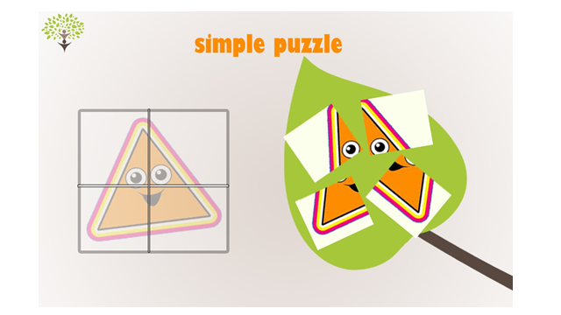

**Figure ‎4.2.7: game 1 in simple level of puzzle**

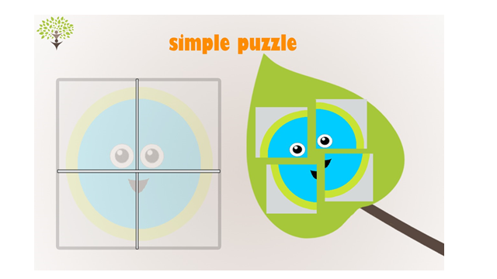

**Figure ‎4.2.8 : Game 2 in Simple Level of Puzzle**

#### Median Level of puzzle interfaces

This level includes two games, the specialist has to select one of them ( Figure ‎4.2.9 ) then the child can play the puzzle, see ( Figure ‎4.2.10,Figure ‎4.2.11). 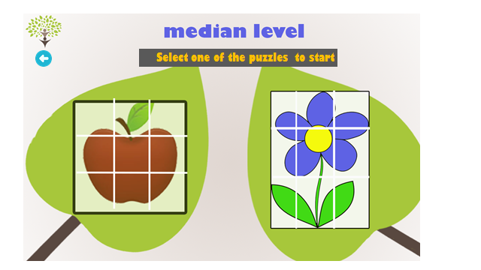

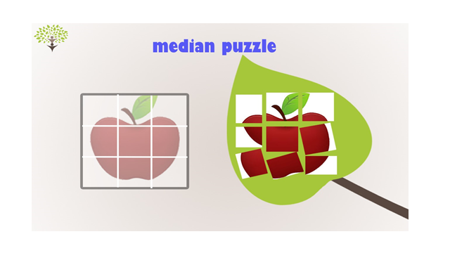

**Figure ‎4.2.10 : Game 2 in Median Level of Puzzle**

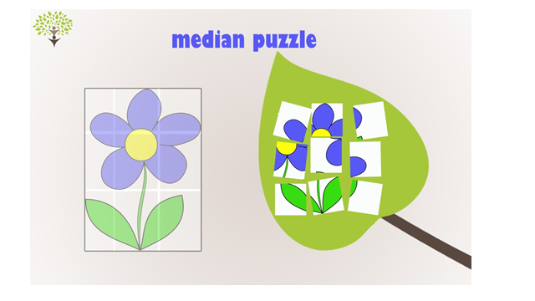

**Figure ‎4.2.11 :Game 2 in Median Level of Puzzle**

#### Advanced Level of puzzle interfaces

This level includes two games, the specialist has to select one of them ( Figure ‎4.2.12) then the child can play the puzzle, see (Figure ‎4.2.13,Figure ‎4.2.14).

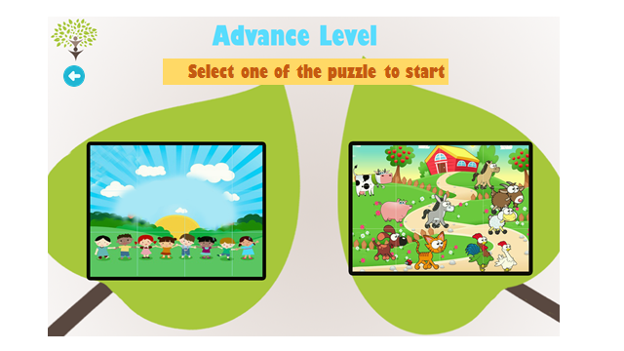

**Figure ‎4.2.12 : Select the Puzzle**

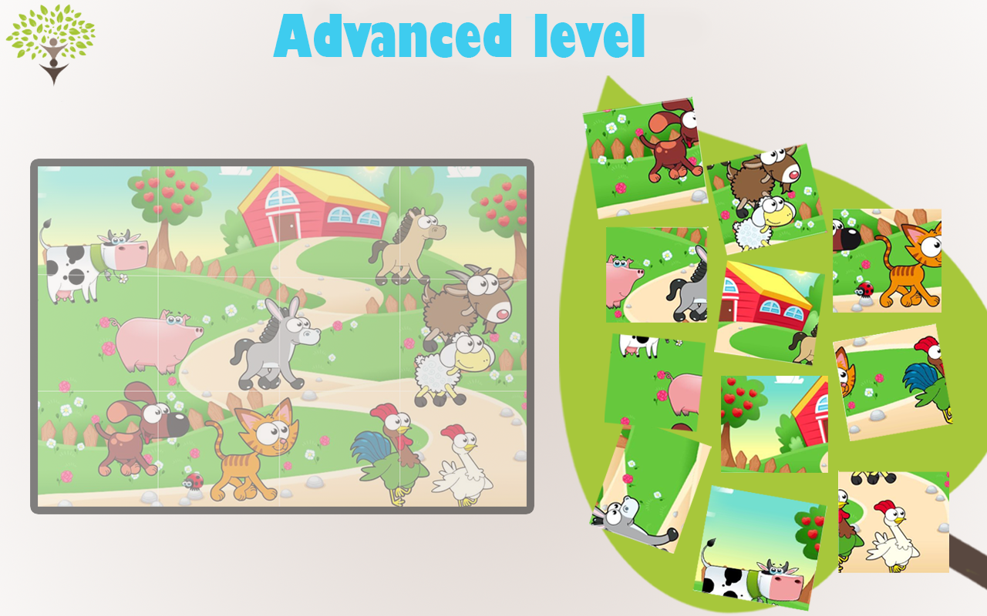

**Figure ‎4.2.13 : Game 1 in Advanced Level of Puzzle**

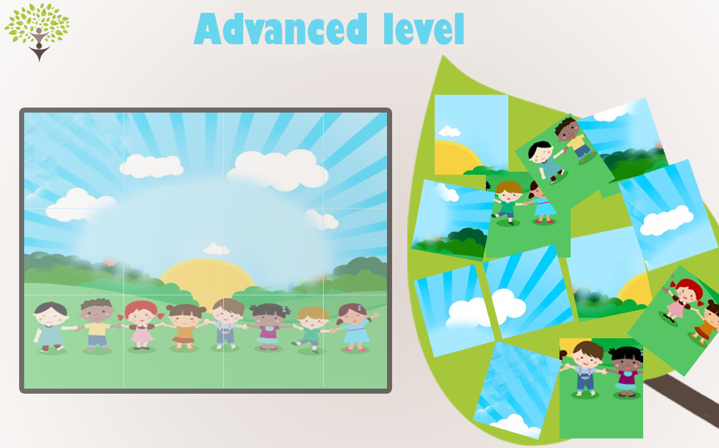

**Figure ‎4.2.14 : Game 2 in Advanced Level of Puzzle**

### Pattern Matching Category

This category presents a game which consists of a set of images with one, two or three masking images depending on levels which chosen by the specialist, where the child chooses the correct image according to the options which displayed in front of where they are accordance to the given context.

#### Simple Level of Pattern Matching Interfaces

The specialist has to choose one of the two presented games in this level. Each consists of set of patterns ,see ( Figure ‎4.2.15 ) then the game will be played by asking the child to choose the correct image to complete the pattern .Only one masking image will be used in this level , see ( Figure ‎4.2.16,Figure ‎4.2.17) .

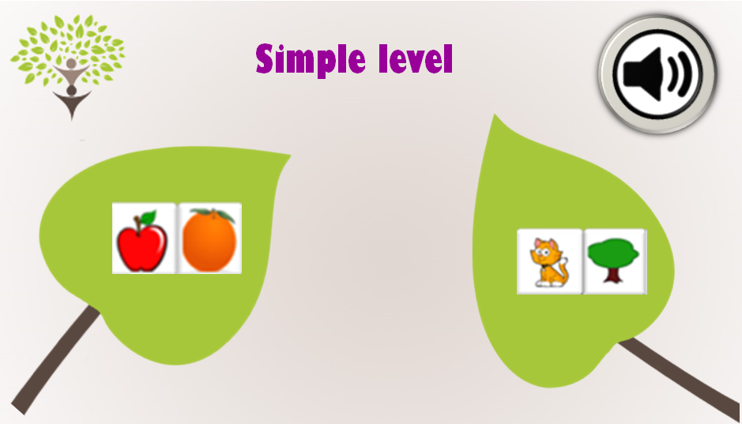

**Figure ‎4.2.15 : Select the Game**

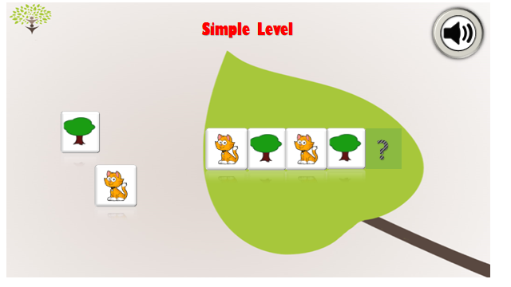

**Figure ‎4.2.16 : Game 1 in Simple Level of Pattern Matching**

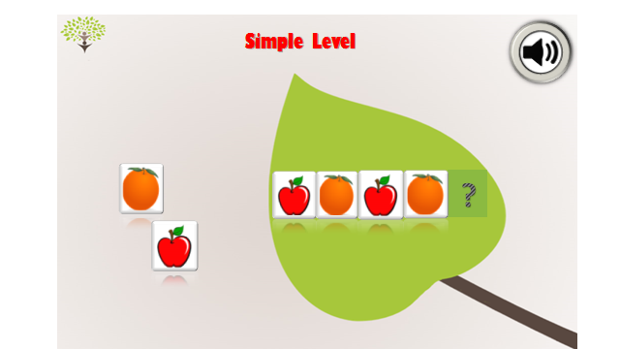

**Figure ‎4.2.17 : Game 2 in Simple Level of Pattern Matching**

#### Median Level of Pattern Matching Interfaces

In this level two masking images have to be filled by the correct images which will be chosen by the child to complete the pattern in a correct way .see ( Figure ‎4.2.18 ), see ( Figure ‎4.2.19,Figure ‎4.2.20)

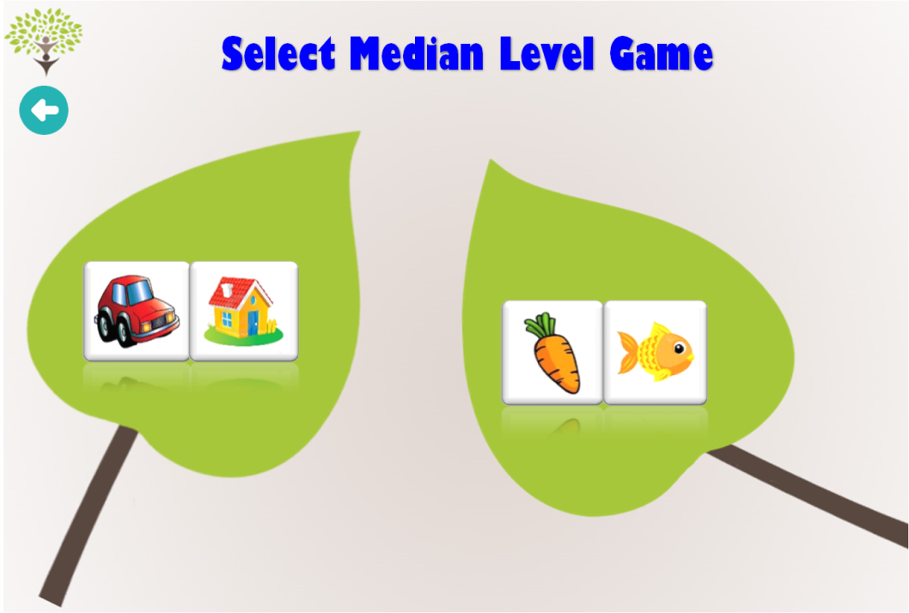

**Figure ‎4.2.18 : Select the Game**

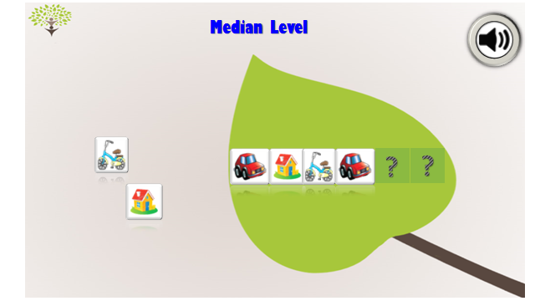

**Figure ‎4.2.19 : Game 1 in Median Level of Pattern Matching**

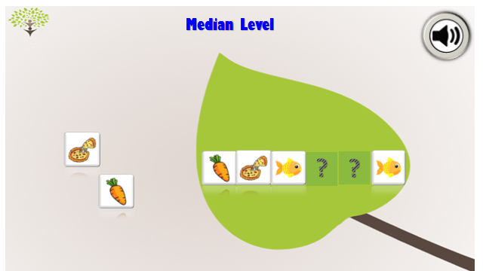

**Figure ‎4.2.20 : Game 2 in Median Level of Pattern Matching**

#### Advanced Level of Pattern Matching Interfaces

In this level three masking images will be asked to be filled with the correct images by the child. see ( Figure ‎4.2.21, Figure ‎4.2.22 and Figure ‎4.2.23).

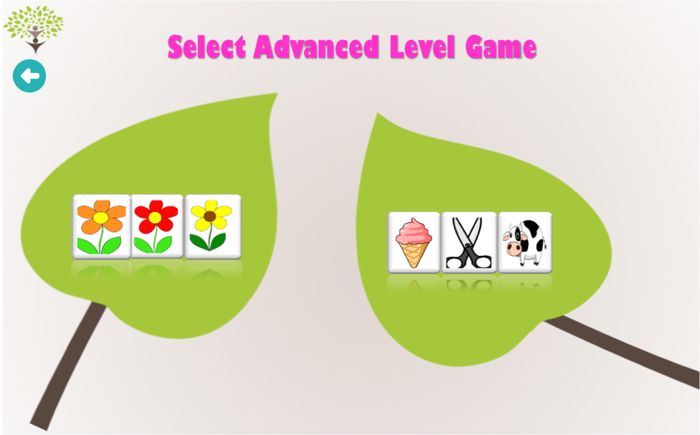

**Figure ‎4.2.21 : Select the Game**

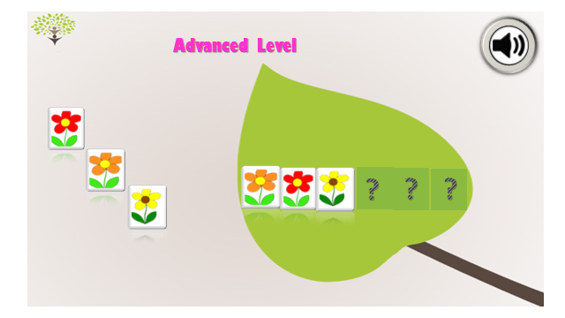

**Figure ‎4.2.22 : Game 1 in Advanced Level of Pattern Matching**

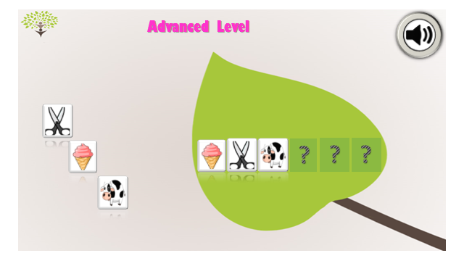

**Figure ‎4.2.23: Game 2 in Advanced Level of Pattern Matching**

Main Features:

design the UI as shown in the above screenshots.

Zoom in the the image after the child passes the level successfully.

Drag and drop images (puzzle game)